**Streamlit**

* Streamlit is an open-source Python library that makes it easy to create and share custom web apps.
* Install Streamlit
  + pip install streamlit

**Program#1**

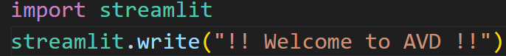

**Program#2**

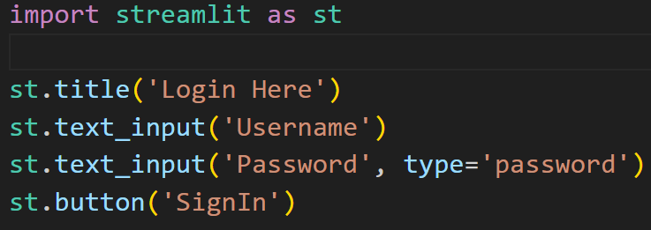

**Program#3**

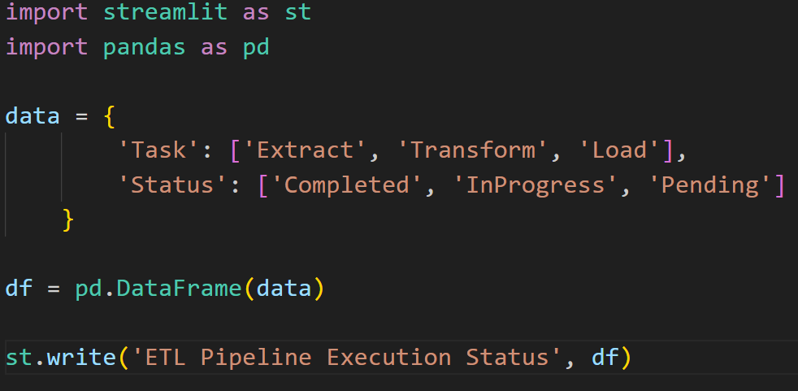

**Program#4**

import streamlit as st

import pandas as pd

data = pd.read_csv('data.csv')

st.write('Original Data', data)

missing_data = data.isnull().sum().reset_index()

missing_data.columns = ['Column', 'Missing Values']

st.write('Missing Values', missing_data)

**Deploy Streamlit Application**

* Create EC2 instance in AWS cloud platform
  + AMI: Amazon AWS
* Copy Code from local machine to EC2 instance
* Install Python
  + sudo yum install python3-pip
* Install Streamlit
  + pip install streamlit
* Open ports to access Streamlit application from internet
  + Inbounds Rules
    - Add 8501 port in inbounds rule
* Access streamlit application from anywhere
  + <http://public_ip_of_ec2:8501>